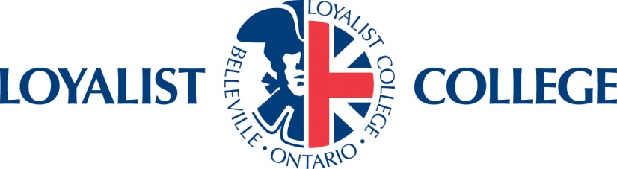
Renewal/Amendment Request Form

Please complete and submit this form to Cher Powers, Research Ethics Board Coordinator at (613) 969-1913, x2108, or email to: cpowers@loyalistcollege.com

This form may be used to request REB approval to:

1. Renew Approval
Extend the time limit of an approved project currently underway before REB approval expires. (Note: The Loyalist College REB approves projects for one year. If your REB approval has lapsed and you require an extension to your REB approval, you must re-submit the entire application to the REB.)

2. Request Approval of an Amendment
a) Make minor changes or amendments to the protocol of an approved project.
b) Appoint a new Principal Investigator (PI), or add new co-investigator(s).
(Note: Only the current approved PI may use this form to request appointment of a new PI. If the current PI is not making the request, a new REB application should be submitted.)
c) Change the project title, the name of the funding agency or sponsor.
(Note: In all cases the name of the PI and project title must exactly match what is shown on the grant application to the funding agency, and the funding agreement with the sponsor.)

1. General Project Information

Title of Research Project:

01-Jan-2015
Today’s Date:
01-Jan-2015
Date of Original Ethics Approval:
01-Jan-2015
Is a new end date required? Yes No New end date:

Reason for date extension:

Has another REB renewed the ethics approval for this project? Yes No
If yes, please provide a copy of the re-approval letter.

What is the current status of the study?

Research participants are currently being recruited
Recruitment is complete but participants are actively participating in research
Research participant involvement is complete and data is being analyzed/prepared for
publication (Note: If study is complete, please use the “Project Termination Form”)

Please provide a brief synopsis of the progress with the study to date:

2. Investigator Information
(Name, Phone, Email)
Principal investigator:

New Principal Investigator (if applicable or N/A )

Name:
Phone:
E-mail:
Affiliation:

I request that this project be placed under the direction of the new Principal Investigator as named above.
01-Jan-2015
Signature of current PI: _____________________________________ Date:

01-Jan-2015
Signature of Dean/Supervisor: _______________________________ Date:

New Principal Investigator (if applicable or N/A )

Name:
Phone:
E-mail:
Affiliation and Role:

3. Funding Information

Have there been any changes or additions to the funding? Please check is N/A
Please Describe.

4. Amendments to Project

Please check if no amendments have been made to the project

Modification to recruitment procedure
Modification to informed consent document or procedure
Modification to study design or methods
Modification to study instruments or data collection methods
Other change to the research study.
Please provide details of any proposed changes to the project. Please include the any new forms including consents, recruitment tools (ie. letters, posters) or data collection tools (ie. questionnaires, test, surveys). Note: Amendments may not be implemented until approved by the REB.

5. Problems Encountered During Research

Please check if there have been no significant problems
Please describe any problems during the study including issues with participant recruitment, complaints from research participants, participant withdrawals, unexpected harms or effects to participants or any other ethical concerns. Describe how any problems were resolved.

Principal Investigator (PI) Assurance:

I, ____________________________ [PLEASE PRINT] have the ultimate responsibility for the conduct of the study described in this application including my responsibilities as an advisor to any students involved in this project. I have read and am responsible for the content of this application. The information provided is complete and accurate. I understand that, as Principal Investigator, I will be the primary link with the REB, other researchers involved with this project, and the research participants. I agree to conduct the research in accordance with the Tri-Council Policy Statement: Ethical Conduct for Research Involving Humans and by the Policies and Procedures at Loyalist College for Ethical Conduct of Research.

I also understand that if I make any additional changes whatsoever to the sample documents provided with this application (including, but not limited to, the recruitment scripts, information and consent letters, survey questions, interview or focus group questions), I need to complete a change request form and submit this to the REB for review. I further understand that these changes, if determined to be substantive by the REB, may require a new application if they constitute new research. If any changes are made in the above arrangements or procedures, or if adverse events are observed, I will bring these to the attention of the Research Ethics Coordinator immediately.

I understand that if I fail to advise the REB of any changes or adverse events, or fail to comply with research protocols outlined in this application, or make any unauthorized changes to any document submitted with this application, the Certificate of Ethical Acceptability may be rescinded by the REB.

_________________________________ __________________
Signature of Principal Investigator Date

Please email a copy with signature to:

Cher Powers - Research Ethics Board Coordinator
cpowers@loyalistcollege.com

Loyalist College Applied Arts and Technology
376 Wallbridge-Loyalist Road
P.O Box 4200
Belleville, ON
K8N 5B9
(613) 969-1913, x2108

REB Use Only

Request Decision: Approved Approved with Recommendations Denied

Comments:

_________________________________ __________________
Signature of REB Chair Date

